COMPARATIVE EFFECTIVENESS OF ULTRASONIC-ACTIVATED IRRIGANTS FOR SMEAR LAYER REMOVAL IN ENDODONTICS: A SYSTEMATIC REVIEW AND META-ANALYSIS

ABSTRACT
The smear layer is a residual layer formed after root canal preparation and can inhibit the penetration of irrigants, intracanal medicaments, and sealer materials into the dentinal tubules. Ultrasonic-based irrigant activation has been widely used to improve the effectiveness of root canal cleaning; however, primary study findings still vary depending on the type of irrigant, activation technique, root canal morphology, and evaluation site. This study aims to analyze the comparative effectiveness of ultrasonic-activated irrigants on smear layer removal in endodontic treatment through a systematic literature review and meta-analysis. The article search was conducted in PubMed/MEDLINE, Scopus, and Web of Science for articles published from 2017 onward. Article selection followed the PRISMA 2020 flow, with a total of 228 articles identified, 5 duplicates removed, 223 articles screened, 58 articles assessed in full text, and 12 articles meeting the inclusion criteria. The extracted data included author, year, study design, irrigation technique, SEM/FESEM evaluation method, odds ratio (OR), confidence interval (CI), p-value, and I². The meta-analysis results showed a pooled effect of 1.28 with a 95% CI of 0.68–1.89 and p < 0.001. Heterogeneity was low to moderate, with an I² value of 32.38% and Q(11) = 15.43; p = 0.164. These findings indicate that ultrasonic-activated irrigants significantly improve the effectiveness of smear layer removal compared with conventional irrigation, although their effectiveness is still influenced by the type of irrigant and comparator technique.
Keywords: Endodontics; Ultrasonic activation; Passive ultrasonic Irrigation; Smear layer removal.
INTRODUCTION
Endodontic treatment aims to preserve teeth through thorough cleaning, disinfection, and tight obturation of the root canal system. The success of this procedure is not only determined by the ability of instruments to shape the root canal, but also by the effectiveness of irrigation in cleaning areas that are not reached by instruments. Mechanical preparation produces a smear layer consisting of dentin debris, pulp tissue, microorganisms, necrotic remnants, and other organic-inorganic components attached to the root canal walls. This layer can occlude dentinal tubules, inhibit the penetration of irrigating agents, reduce the effectiveness of intracanal medicaments, and limit the adaptation of sealer materials during obturation. Paixão et al. (2022) emphasized that the smear layer reduces the ability of irrigants and intracanal medicaments to adequately penetrate dentinal tubules, while Atav et al. (2025) explained that the smear layer contains dentin particles, pulp tissue remnants, and microbial elements that may interfere with the penetration of irrigants and sealers.
Smear layer removal is an important issue because root canal cleaning cannot rely on instrumentation alone. The anatomical configuration of root canals, which may be narrow, oval, curved, or contain isthmuses, leaves some dentin surfaces untouched by instruments; therefore, irrigation plays a major role in reaching these areas. Chu et al. (2023) explained that root canal walls in narrow anatomical areas may remain unprepared after instrumentation, making soft tissue remnants and biofilm difficult to remove through mechanical preparation alone. Paixão et al. (2022) also reported that nearly 60% of root canal surfaces may remain untouched by rotary instruments, making complete cleaning and disinfection difficult to achieve through mechanical preparation alone. This condition indicates that irrigation effectiveness should be assessed not only based on the type of solution used, but also on how the solution is activated throughout all thirds of the root canal.
Sodium hypochlorite and EDTA remain the most widely used irrigant combination because they have different functions. Sodium hypochlorite is effective in dissolving organic tissue and providing antimicrobial effects, but it is unable to optimally remove the inorganic components of the smear layer. EDTA acts as a chelating agent that targets the mineral component of the smear layer, opens dentinal tubules, and increases dentin permeability to support the penetration of disinfecting agents and sealers. Mohammadi et al. (2017) stated that sodium hypochlorite is the most commonly used irrigant, but it has limitations because it cannot remove the smear layer. Atav et al. (2025) explained that the sequential use of NaOCl and EDTA aims to combine the tissue-dissolving ability of NaOCl with the removal of inorganic smear layer components by EDTA.
Although the selection of irrigation solution is important, cleaning effectiveness is also influenced by the activation technique. Conventional irrigation using a needle and syringe often has flow limitations, especially in the narrow apical third, which is far from coronal access. Ultrasonic-activated irrigation or passive ultrasonic irrigation works through high-frequency vibration that produces acoustic microstreaming, cavitation, and shear stress against the root canal walls. These mechanisms help move the irrigating solution, increase irrigant contact with the dentin surface, and detach debris remaining after preparation. Chu et al. (2023) stated that ultrasonic-activated irrigation operates at a frequency of 25,000–40,000 Hz and produces cavitation and acoustic microstreaming, while Atav et al. (2025) explained that PUI is one of the activation methods widely used to improve irrigant penetration and agitation.
Urban et al. (2017), Mancini et al. (2018), and Neelakantan et al. (2019) showed that the effectiveness of root canal cleaning is influenced by the type of activation system, observation site, and experimental design. Urban et al. (2017) assessed canal cleanliness using SEM in the coronal, middle, and apical thirds after the use of several irrigation activation systems. Mancini et al. (2018) compared EndoActivator, EndoVac, PUI, and LAI using FESEM to evaluate smear layer removal ability. Neelakantan et al. (2019) tested irrigation strategies for smear layer removal from root canal dentin and reinforced the role of irrigant activation as an important step after mechanical preparation. These three studies showed a similar direction, namely that irrigant activation can improve root canal cleanliness; however, the results across techniques are not always consistent because of differences in protocols, tooth types, canal morphology, irrigant concentration, activation duration, and scoring systems.
Koçak et al. (2017) investigated the effect of passive ultrasonic irrigation on the efficiency of various irrigating solutions in removing the smear layer using scanning electron microscopy. Orlowski et al. (2020) later evaluated PUI with EDTA followed by conventional irrigation using two concentrations of NaOCl, with a five-group design, n = 10 per group, a four-level debris score, and Kruskal-Wallis and Dunn tests. Widbiller et al. (2023) expanded the discussion by assessing irrigant activation in relation to smear layer removal and dentin surface disintegration, showing that activation can improve irrigant penetration but also needs to be considered carefully because some techniques may cause changes to the dentin surface. This series of findings confirms that ultrasonic activation cannot be evaluated only based on its ability to remove the smear layer, but also based on its safety for dentin structure.
Existing synthesis studies have not fully addressed the need for a specific comparison of ultrasonic-activated irrigants for smear layer removal. Paixão et al. (2022) compared sonic and ultrasonic activation, with outcomes such as root canal cleanliness, smear layer score, debris score, irrigant penetration, and push-out bond strength. Chu et al. (2023) compared EDDY with ultrasonically activated irrigation and reported that the meta-analysis of smear layer removal used standardized mean difference in the coronal, middle, and apical thirds. Badami et al. (2023) reviewed laser-activated irrigation compared with ultrasonic-activated irrigation, so its focus was more directed toward comparisons between activation technologies. A research gap remains because no synthesis has specifically focused on the effectiveness of various ultrasonic-activated irrigants on smear layer removal, particularly when irrigants, root canal locations, SEM/FESEM scoring systems, and quantitative effect sizes are mapped separately for meta-analysis purposes. This study aims to analyze the comparative effectiveness of ultrasonic-activated irrigants on smear layer removal in endodontic treatment through a systematic literature review and meta-analysis, considering the type of irrigant, root canal location, assessment method, and quantitative effect sizes that can be statistically pooled.

RESEARCH METHOD
This study used a systematic literature review and meta-analysis design to analyze the comparative effectiveness of ultrasonic-activated irrigants on smear layer removal in endodontic treatment. This design was selected because the study not only mapped findings from previous articles, but also combined quantitative data from primary studies comparing ultrasonic irrigation with conventional irrigation or other irrigant activation methods. The meta-analysis was directed toward obtaining a stronger effect estimate regarding the ability of ultrasonic-activated irrigation to improve smear layer cleaning success. The reporting of this study referred to the PRISMA 2020 guidelines because these guidelines are used to improve the completeness of reporting in systematic reviews and meta-analyses, particularly at the stages of identification, screening, eligibility assessment, and inclusion of scientific articles. Page et al. (2021) explained that PRISMA 2020 was designed to help researchers transparently report why the review was conducted, what methods were used, and what results were found.
The quantitative analysis was conducted based on the principles of meta-analysis for experimental interventions, namely the pooling of effect sizes from primary studies with comparable sample populations, interventions, comparators, and outcomes. This study focused on articles reporting statistical data in the form of odds ratios (OR), p-values, and confidence intervals (CI), or raw data that could be converted into OR. In endodontic studies, smear layer removal outcomes are often reported as SEM/FESEM scores. Therefore, score data were converted into dichotomous outcomes, namely effective and ineffective cleaning categories. Effective cleaning was defined as a low smear layer score or a cleaner dentin surface category, while ineffective cleaning was defined as moderate to severe smear layer scores. This approach allowed articles with different scoring systems to be analyzed in the form of OR, CI, and p-value.
The research stages included: (1) formulation of the meta-analysis question, (2) article search in scientific databases, (3) article selection based on inclusion and exclusion criteria, (4) quantitative data extraction, (5) risk of bias assessment, (6) effect size calculation, (7) heterogeneity analysis, and (8) interpretation of the meta-analysis results. The article search process was conducted systematically in three major databases most relevant to dentistry, endodontics, and biomedical research, namely PubMed/MEDLINE, Scopus, and Web of Science. The search was limited to articles published from 2017 onward, articles written in English and/or Indonesian, peer-reviewed articles, and primary studies with quantitative designs such as in vitro experimental studies, ex vivo studies, comparative experimental studies, and randomized laboratory studies. Articles in the form of systematic reviews, scoping reviews, meta-analyses, narrative reviews, editorials, letters to the editor, case reports, and articles that did not provide quantitative statistical data were not included as primary data.
Keyword development is carried out using the PICO approach as follows.
Table 1. PICO Research
Component | Information
P (Population) | Human permanent tooth samples, root canals, root canal dentin, or endodontic specimens undergoing root canal preparation and smear layer evaluation.
I (Intervention) | Ultrasonic-activated irrigants, passive ultrasonic irrigation, ultrasonic activation, or ultrasonic activation using irrigants such as EDTA, NaOCl, QMix, or other chelating solutions.
C (Comparison) | Conventional irrigation using a needle/syringe, manual dynamic activation, sonic activation, laser activation, EndoActivator, EndoVac, EDDY, XP-Endo Finisher, or other non-ultrasonic activation methods.
O (Outcome) | The success of smear layer removal, SEM/FESEM smear layer score, cleanliness of the root canal walls, cleanliness of the coronal, middle, and apical thirds, and the number of specimens with effective cleaning can be converted into OR, CI, and p-value.
Keywords were combined using the Boolean operators AND and OR. The search strategy was designed to retrieve articles discussing ultrasonic-activated irrigation, types of endodontic irrigants, smear layer removal, and statistical data that could be used in the meta-analysis. The main search strategy used a combination of the following terms: “ultrasonic irrigation,” “passive ultrasonic irrigation,” “ultrasonic activation,” “activated irrigant,” “smear layer removal,” “endodontics,” “root canal,” “EDTA,” “sodium hypochlorite,” “QMix,” “SEM,” “FESEM,” “odds ratio,” “confidence interval,” and “p-value.”
Table 2. Number of Articles by Search Database
Database | Keyword | Number of Articles
PubMed/MEDLINE | (“passive ultrasonic irrigation” OR “ultrasonic irrigation” OR “ultrasonic activation” OR “ultrasonic-activated irrigant”) AND (“smear layer removal” OR “smear layer” OR “root canal cleanliness”) AND (endodontics OR “root canal treatment” OR “root canal dentin”) AND (EDTA OR NaOCl OR “sodium hypochlorite” OR QMix OR irrigant) AND (“odds ratio” OR “confidence interval” OR “p-value” OR SEM OR FESEM) | 64
Scopus | TITLE-ABS-KEY (“passive ultrasonic irrigation” OR “ultrasonic irrigation” OR “ultrasonic activation” OR “irrigant activation”) AND TITLE-ABS-KEY (“smear layer removal” OR “smear layer score” OR “canal cleanliness”) AND TITLE-ABS-KEY (endodontics OR “root canal” OR “root canal dentin”) AND TITLE-ABS-KEY (EDTA OR NaOCl OR QMix OR irrigant) AND PUBYEAR > 2016 | 91
Web of Science | TS=(“passive ultrasonic irrigation” OR “ultrasonic activation” OR “ultrasonic-activated irrigation”) AND TS=(“smear layer removal” OR “smear layer score” OR “root canal cleanliness”) AND TS=(endodontics OR “root canal treatment” OR “root canal dentin”) AND TS=(EDTA OR NaOCl OR QMix OR irrigant) | 73
Total articles identified |  | 228
The initial search in PubMed/MEDLINE, Scopus, and Web of Science yielded 228 articles, consisting of 64 articles from PubMed/MEDLINE, 91 articles from Scopus, and 73 articles from Web of Science. After duplicate checking, 5 duplicate articles were identified, leaving 223 articles for the title and abstract screening stage. At this stage, 165 articles were excluded because they were not relevant to the research focus, did not discuss ultrasonic-activated irrigation, did not evaluate smear layer removal, did not use endodontic samples, did not report statistical data that could be converted into OR, CI, and p-value, or had inappropriate publication designs, such as reviews, meta-analyses, editorials, and case reports. Therefore, 58 articles proceeded to the full-text assessment stage.
The PRISMA diagram was used to illustrate the number of articles obtained from each database, duplicate articles removed, articles excluded during the screening stage, articles assessed in full text, and final articles included in the quantitative meta-analysis. PRISMA 2020 provides a flow diagram template for reporting the identification, screening, and inclusion process of articles in systematic reviews.

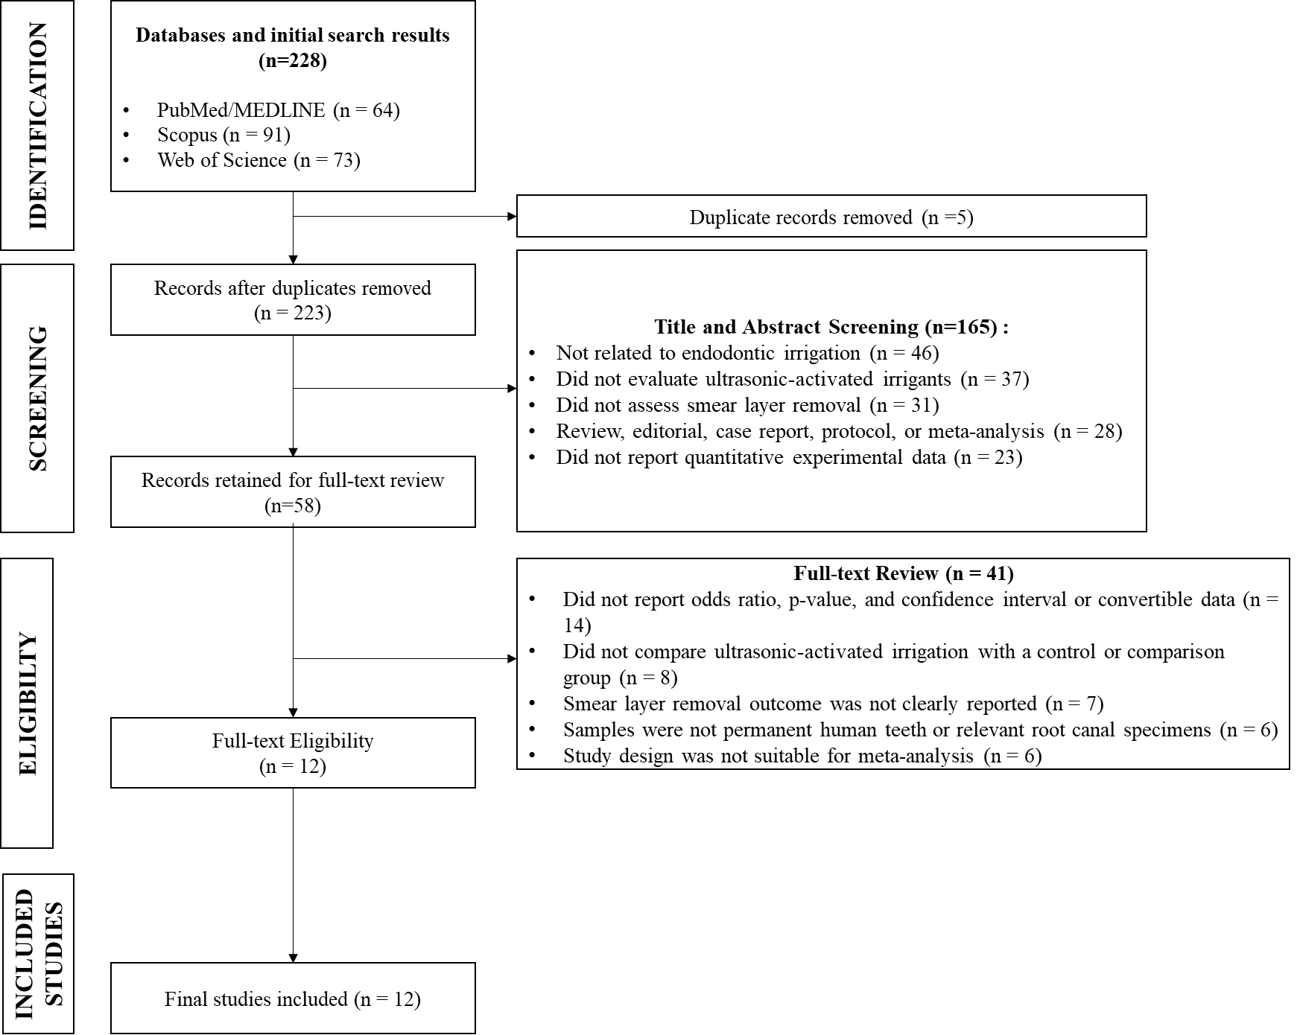
Figure 1. PRISMA diagram
At the full-text evaluation stage, 46 articles were excluded because they did not meet the eligibility criteria. Articles that did not provide OR, p-value, and CI values or data that could be converted into OR were excluded because they could not be used in the quantitative analysis. Articles that only presented descriptive scores without reporting the number of specimens in the effective and ineffective cleaning categories were also not included in the meta-analysis, unless their tabulated data allowed OR recalculation. After the entire selection process was completed, 12 articles met the inclusion criteria and were included in the meta-analysis.
The inclusion criteria in this study were: (1) articles published from 2017 onward; (2) articles were primary quantitative studies; (3) articles used human permanent teeth or root canal samples relevant to endodontic procedures; (4) articles discussed the effectiveness of ultrasonic-activated irrigation or passive ultrasonic irrigation on smear layer removal; (5) articles had a comparator group such as conventional irrigation or non-ultrasonic activation techniques; (6) articles reported OR, p-value, and CI values or data that could be calculated into OR; (7) articles were available in full text; and (8) articles were written in English or Indonesian.
The exclusion criteria were: (1) articles in the form of reviews, systematic reviews, meta-analyses, editorials, letters to the editor, protocols, case reports, or scientific commentaries; (2) articles that did not compare ultrasonic irrigation with a comparator group; (3) articles that did not evaluate smear layer removal; (4) articles that only discussed sealer penetration, bond strength, antibacterial effects, or debris without smear layer data; (5) articles that did not provide statistical data that could be converted into OR, CI, and p-value; and (6) duplicate articles from the same dataset.
Data extraction was performed using Microsoft Excel by recording the author’s name, publication year, country, study design, sample size, tooth type, root canal type, irrigant type, activation technique, comparator group, root canal evaluation site, SEM/FESEM assessment method, number of specimens with effective and ineffective cleaning, OR, p-value, CI, and I² value. The final data were organized so that they could be directly used in the meta-analysis using JASP, with OR as the main effect measure, CI as the precision limit of the estimate, p-value as the indicator of statistical significance, and I² as the indicator of heterogeneity across articles.

RESULTS AND DISCUSS
Research Research
The initial synthesis results from the 12 articles that met the inclusion criteria in the systematic literature review and meta-analysis are presented. The results are shown in the form of an article summary to describe the objectives, methods, main findings, and conclusions of each study that served as the basis for the scientific synthesis.
Table 3. Frequency Distribution of SLR Article Characteristics
Characteristics | Category | Frequency (n=12) | Percentage (%)
Year of publication | 2017 | 3 | 25,00
 | 2018 | 1 | 8,33
 | 2020 | 1 | 8,33
 | 2021 | 3 | 25,00
 | 2022 | 2 | 16,67
 | 2023 | 1 | 8,33
 | 2024 | 1 | 8,33
Research design | In vitro / ex vivo experimental study | 12 | 100,00
Smear layer evaluation method | Scanning Electron Microscopy (SEM) | 10 | 83,33
 | Field Emission Scanning Electron Microscopy (FESEM) | 2 | 16,67
Main techniques analyzed | Passive/ultrasonic-activated irrigation | 12 | 100,00
 | Continuous ultrasonic irrigation | 2 | 16,67
 | Sonic/mechanical activation sebagai pembanding | 9 | 75,00
 | Laser-activated irrigation sebagai pembanding | 2 | 16,67
Table 1 shows that the analyzed articles were published between 2017 and 2024, with the highest number of publications in 2017 and 2021, each consisting of 3 articles or 25.00%. All articles used an in vitro or ex vivo experimental study design, totaling 12 articles or 100.00%, indicating that the characteristics of the reviewed studies were relatively homogeneous in terms of experimental design. The most commonly used method for smear layer evaluation was Scanning Electron Microscopy (SEM), reported in 10 articles or 83.33%, while FESEM was used in 2 articles or 16.67%. All articles analyzed passive/ultrasonic-activated irrigation as the main technique, while sonic/mechanical activation was used as a comparator in 9 articles or 75.00%, continuous ultrasonic irrigation in 2 articles or 16.67%, and laser-activated irrigation in 2 articles or 16.67%.
Table 4. Summary of Systematic Literature Review Results of 12 Final Articles
Author (Year) | Objective | Method | Results | Conclusion
Urban et al. (2017) | To assess the effectiveness of several final irrigation activation methods for removing debris and smear layer in the apical, middle, and coronal thirds of straight root canals. | Experimental SEM research with manual irrigation, EndoActivator, EDDY, and passive ultrasonic irrigation groups. | PUI and EDDY showed better smear layer scores than manual irrigation, while all activation methods produced cleaner root canal walls than manual irrigation. | Irrigant activation improves root canal cleanliness, but not all techniques are able to completely remove the smear layer.
Prado et al. (2017) | Evaluating the use of auxiliary devices, namely ultrasonically activated irrigation and EasyClean, to improve the cleaning ability of chelating agents. | SEM experimental research using QMix with conventional irrigation, EasyClean, and ultrasonically activated irrigation. | There were significant differences between groups; UAI demonstrated better cleaning performance than EasyClean and both were better than conventional irrigation. | Ultrasonically activated irrigation is more effective in supporting the work of chelating agents in cleaning the smear layer.
Poletto et al. (2017) | Evaluating smear layer removal by various chemical solutions with or without ultrasonic activation after post preparation. | Experimental study on uniradicular mandibular premolar teeth; smear layer evaluated by SEM after application of chemical solution and ultrasonic activation. | The article provides a comparison of smear layer scores between solutions and between conditions with/without ultrasonic activation after post preparation. | The effectiveness of smear layer removal is influenced by the type of chemical solution and the use of activation, so it is worth including as a quantitative comparison.
Mancini et al. (2018) | Comparing the effectiveness of EndoActivator, EndoVac, PUI, and laser-activated irrigation in removing the smear layer from root canals. | In vitro study on uniradicular mandibular premolars; evaluation was performed with FESEM at distances of 1, 3, 5, and 8 mm from the apex. | EndoActivator was more effective than PUI, LAI, and control at 3, 5, and 8 mm; EndoVac was more effective at 1 mm from the apex. | EndoVac and EndoActivator showed better cleaning results at some levels of the root canal, but neither technique completely removed the smear layer.
Haupt et al. (2020) | Evaluating the effectiveness of several irrigation activation techniques on debris and smear layer in curved root canals. | SEM study on 90 mandibular molars with 20–40 degrees curvature; groups consisted of syringe irrigation, PUI, EDDY, EndoActivator, and control. | Irrigant activation significantly improved smear layer removal; EndoActivator and EDDY were more effective for debris than syringe irrigation. | Irrigation activation gives better results than syringe irrigation, but neither technique is able to remove all debris and smear layer in curved root canals.
Machado et al. (2021a) | Comparing smear layer removal by conventional irrigation, passive ultrasonic irrigation, and continuous ultrasonic irrigation with 17% EDTA. | In vitro SEM study on uniradicular mandibular canines; groups consisted of control, CI, PUI, and CUI. | The article provides smear layer scores based on the Torabinejad criteria in conventional, passive ultrasonic, and continuous ultrasonic irrigation groups. | PUI and CUI can be compared directly with conventional irrigation as a basis for synthesizing the effectiveness of ultrasonic-activated irrigants.
Machado et al. (2021b) | Comparing smear layer removal by conventional application, PUI, EasyClean, and XP-Endo Finisher using 17% EDTA. | In vitro study on 45 uniradicular mandibular premolars; SEM ×1,000 was used on each third of the root and analyzed by Kruskal-Wallis and Dunn tests. | In the apical third there was no significant difference between the groups; in the cervical and middle thirds the experimental group performed better than the control, but conventional application of EDTA showed better results than PUI, EasyClean, and XP-Endo Finisher. | No method was able to completely remove the smear layer, especially in the apical third; conventional EDTA application performed better than activation in this design.
Mancini et al. (2021) | To assess the effectiveness of various irrigant activation methods, namely EndoActivator, PUI, PIPS, and SWEEPS, in conservatively prepared root canals. | Ex vivo FESEM study of mandibular premolars; smear layer was assessed at 1, 3, 5, and 8 mm from the apex. | PIPS and SWEEPS showed the best results in conservative root canal preparation; PIPS was superior in certain critical areas compared to EA and PUI. | In conservatively prepared root canals, irrigant activation is an important step, with PIPS and SWEEPS showing the strongest performance compared to sonic activation and PUI.
Miguéns-Vila et al. (2022) | Assessing the effectiveness of various irrigant activation systems on smear layer removal using SEM. | SEM experimental study comparing PUI, CUI, ANP, and classical irrigation methods. | CUI is more effective than PUI and ANP; the irrigant activation system is more successful in removing the smear layer than classical irrigation methods. | Irrigant activation increases the success of smear layer removal, but no protocol results in completely smear layer-free root canals.
Al-rujaib et al. (2022) | To assess the effectiveness of five irrigant activation systems on root canal cleanliness and smear layer removal. | SEM study on 110 straight mandibular premolars; groups consisted of conventional needle irrigation, PUI, EndoActivator, EndoVac, EDDY, and control. | EndoVac and EDDY were more effective for the smear layer than the other activation groups; irrigant activation significantly improved debris removal. | EDDY demonstrated strong performance in the apical third, but no activation technique was able to completely remove the smear layer and debris.
Wigler et al. (2023) | Comparing the effectiveness of sonic and ultrasonic activation-based final irrigation protocols on debris and smear layer in straight oval root canals. | SEM study on 60 mandibular incisors with oval root canals; groups included EDDY sonic activation, Endosonic PUI, Irrisafe PUI, and syringe irrigation without activation. | No protocol removes all debris and smear layer; syringe irrigation without activation leaves more debris and smear layer in the apical third. | Irrigant activation offers advantages over non-activated syringe irrigation, especially in apical areas that are difficult to clean.
Gonçalves et al. (2024) | Comparing conventional irrigation, PUI, EndoActivator System, and Perfect Clean System in smear layer removal using SEM. | Ex vivo SEM study; irrigation technique groups were compared at several root canal levels. | The article presents a comparison of smear layer scores between conventional irrigation, PUI, EndoActivator, and Perfect Clean System. | Data support a direct comparison between PUI and sonic activation techniques against conventional irrigation for meta-analysis synthesis.
Table 2 shows that the 12 analyzed articles had the same main focus, namely assessing the effectiveness of irrigant activation techniques, particularly passive ultrasonic irrigation or ultrasonic-activated irrigation, in removing the smear layer from root canals. In general, most articles showed that irrigant activation resulted in better root canal cleanliness compared with conventional irrigation or manual syringe irrigation. However, the findings across articles were not entirely consistent, as several studies showed that other techniques such as EndoActivator, EDDY, EndoVac, PIPS, SWEEPS, or continuous ultrasonic irrigation could provide better results under certain conditions, particularly depending on the root canal evaluation site and canal anatomy. The most consistent pattern was that no technique was able to completely remove the smear layer from all parts of the root canal, especially the apical third, which is more difficult to reach. Therefore, this table confirms that irrigant activation makes an important contribution to improving root canal cleaning, although its effectiveness is still influenced by the type of activation, type of irrigant, root canal morphology, and SEM/FESEM evaluation area.
The forest plot results from the 12 analyzed articles were used to assess the effectiveness of ultrasonic-activated irrigants on the success of smear layer removal in root canals. Each horizontal line represents the confidence interval range of each article, while the black box indicates the effect size of each study. Effect values located on the right side of the zero line indicate a tendency to support the effectiveness of ultrasonic-activated irrigation, while values close to or crossing zero indicate results that are not individually significant. The pooled estimate is displayed as a diamond symbol at the bottom of the forest plot.

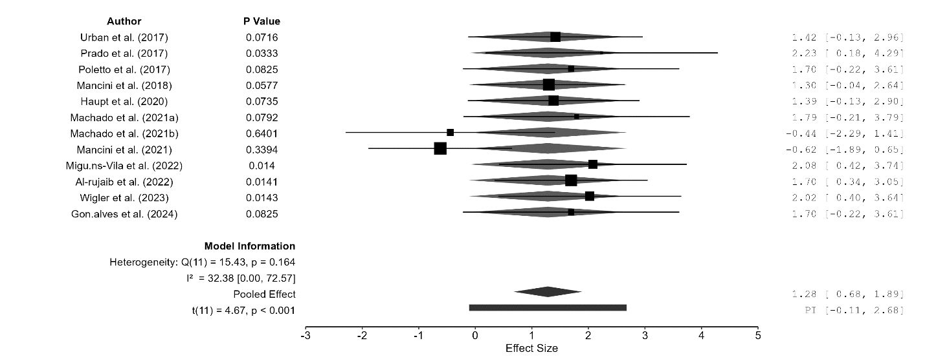
Figure 2. Forest Plot of the Effectiveness of Ultrasonic-Activated Irrigants on Smear Layer Removal
The forest plot results showed that the pooled effect estimate was 1.28 with a 95% CI of 0.68 to 1.89, indicating that ultrasonic-activated irrigants generally had a positive effect on smear layer removal. The value of t(11) = 4.67; p < 0.001 indicated that the pooled effect was statistically significant. Several articles, such as Prado et al. (2017), Miguéns-Vila et al. (2022), Al-rujaib et al. (2022), and Wigler et al. (2023), had confidence intervals that did not cross zero, indicating individually significant effects.
Meanwhile, several other articles, such as Urban et al. (2017), Poletto et al. (2017), Mancini et al. (2018), Haupt et al. (2020), Machado et al. (2021a), and Gonçalves et al. (2024), showed a positive direction of effect but were not individually significant because their confidence intervals still crossed zero. Two articles, namely Machado et al. (2021b) and Mancini et al. (2021), showed negative effects, meaning that the comparator methods in those study designs could provide better results than PUI under certain conditions. The heterogeneity values showed Q(11) = 15.43; p = 0.164 and I² = 32.38%, indicating that variation across articles was low to moderate and not statistically significant. Therefore, this meta-analysis shows that ultrasonic-activated irrigants are generally effective in improving smear layer removal success, although their effectiveness may still be influenced by the type of irrigant, comparator technique, root canal morphology, and SEM/FESEM evaluation site.
The funnel plot was used to assess the possibility of publication bias or imbalance in the distribution of results across articles in the meta-analysis. In this figure, the horizontal axis represents the residual value, while the vertical axis represents the standard error. The dashed vertical line in the center indicates the pooled effect value or estimation center, while the triangular area represents the expected distribution range if the study results are relatively balanced.

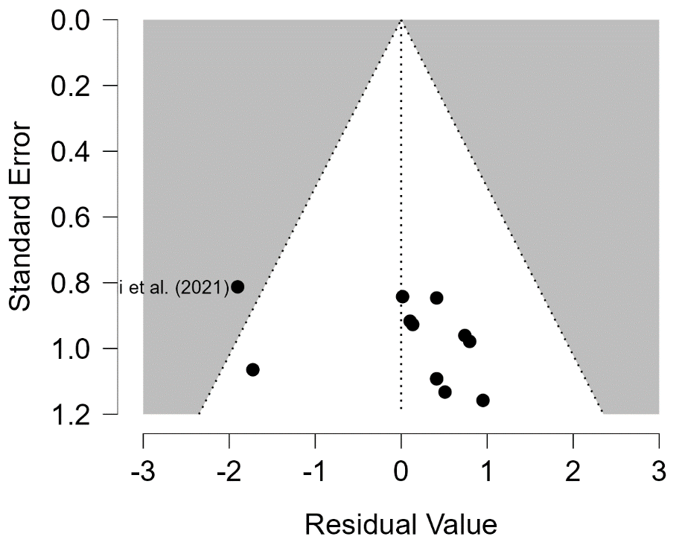
Figure 2. Funnel Plot Diagram
Figure 2 shows that most article points were located on the right side of the center line, while only a few points were distributed on the left side. This pattern indicates funnel plot asymmetry because the distribution of articles did not form a balanced funnel around the center line. One article, namely Mancini et al. (2021), appeared quite far on the left side with a negative residual value, so it can be considered an article that contributed differently compared with most of the other articles. Meanwhile, several other articles clustered at positive residual values with relatively large standard errors, indicating that some studies had lower precision.

Discuss
The meta-analysis results showed that ultrasonic-activated irrigants had a positive direction of effect on the success of smear layer removal in endodontic treatment. The pooled effect value of 1.28 with a 95% CI of 0.68–1.89 and p < 0.001 indicated that ultrasonic activation was statistically associated with improved root canal cleaning effectiveness. When this value is interpreted as a log odds ratio, the direction of effect indicates a greater likelihood of smear layer removal in the activated irrigation group than in the conventional irrigation group. The heterogeneity value of I² = 32.38% with Q(11) = 15.43; p = 0.164 showed that variation across articles was low to moderate, so the differences in results across articles were still acceptable for quantitative synthesis. These findings strengthen the basis that ultrasonic activation is not merely a technical adjunct, but an important approach to improving irrigant distribution, especially after mechanical root canal preparation.
The effectiveness of ultrasonic-activated irrigation can be explained by the increased movement of irrigating solution within the root canal space. Conventional needle irrigation has limited penetration, particularly in the apical third, whereas ultrasonic activation produces more dynamic fluid movement through acoustic streaming and cavitation effects. Gündüz et al. (2025) explained that NaOCl remains the main irrigant because of its antimicrobial and tissue-dissolving abilities, but NaOCl penetration through conventional needle irrigation tends to be limited to the superficial dentin layer; the addition of PUI helps improve irrigant movement and penetration within the root canal system. This finding is consistent with the pattern observed in the 12 analyzed articles, in which most studies showed that the PUI/UAI groups performed better than manual syringe irrigation, although they were not always the most superior technique when compared with sonic activation, EDDY, EndoVac, PIPS, or SWEEPS.
Differences in findings across articles also show that the success of smear layer removal is not only determined by ultrasonic activation, but also by the type of irrigant, root canal morphology, evaluation site, and comparator technique. Al-rujaib et al. (2022) reported that activation with EndoVac and EDDY was more effective than other techniques for smear layer removal, and EDDY showed better results in the apical third; however, no technique was able to completely remove the smear layer and debris. Wang et al. (2024) also showed that PUI and EDDY were more effective than syringe irrigation in the middle and apical thirds, while the Er,Cr:YSGG laser showed the strongest results compared with the other groups. These findings explain why several articles in the forest plot showed significant positive effects, while others had confidence intervals that still crossed the zero line. In other words, ultrasonic activation tends to be effective, but its superiority may change when the comparator used has greater activation energy or a different cleaning mechanism.
The negative results in Machado et al. (2021b) and Mancini et al. (2021) do not necessarily weaken the effectiveness of PUI, but indicate that PUI is not the only technique capable of providing optimal cleaning. In certain study designs, other techniques may produce better irrigant distribution or more effective contact with the dentin walls. Ali et al. (2023) assessed dentinal tubule opening using SEM through intracanal heating activation, sonic activation, and ultrasonic activation, showing that variations in irrigant activation can produce different cleaning responses in the coronal, middle, and apical thirds. Chen et al. (2024) also showed that smear layer removal effectiveness may be influenced by the type of solution, as Triton was reported to be more effective than the EDTA and NaOCl combination in all thirds of the root canal. This strengthens the interpretation that meta-analysis should not only compare “activated” and “non-activated” irrigation, but also consider variations in irrigants and activation protocols as factors influencing effect size.
The results of this study indicate that ultrasonic-activated irrigants have meaningful effectiveness in improving smear layer removal, especially compared with conventional irrigation. However, this effectiveness is not absolute because cleaning outcomes remain influenced by root canal location, SEM/FESEM scoring systems, irrigant type, activation time, and comparator technique. Mochizuki et al. (2024) showed that irrigation success is also influenced by the degree of root canal preparation; conservative instrumentation may reduce cleaning effectiveness, while activation techniques such as PIPS showed good results without damaging the root canal walls. Abaza et al. (2025) added that the Er,Cr:YSGG laser with NaOCl and EDTA can provide highly effective results for smear layer removal. Therefore, PUI should be understood as a strong, safe, and relevant method, while still needing to be openly compared with newer activation techniques.
CONCLUSION
The results showed that ultrasonic-activated irrigants have significant effectiveness in improving the success of smear layer removal in endodontic treatment. Of the 12 articles analyzed, most showed that irrigant activation, particularly passive ultrasonic irrigation, provided better root canal cleaning results than conventional irrigation using syringe/manual irrigation. The meta-analysis showed a pooled effect of 1.28 with a 95% CI of 0.68–1.89 and p < 0.001, indicating a statistically significant positive effect. The I² value of 32.38% indicated low to moderate heterogeneity, meaning that the variation in results across articles was still acceptable for quantitative synthesis.
The implications of this study indicate that ultrasonic activation can be considered an additional protocol in endodontic irrigation procedures, particularly to improve the cleanliness of root canal walls after mechanical preparation. Clinically, the use of ultrasonic-activated irrigation has the potential to improve irrigant distribution, increase contact between the solution and the dentin surface, and enhance the likelihood of smear layer removal in hard-to-reach areas. Academically, this study strengthens the scientific basis that the effectiveness of root canal cleaning depends not only on the type of irrigating solution, but also on the activation method, root canal evaluation site, SEM/FESEM scoring system, and anatomical characteristics of the tooth.
The limitations of this study lie in the dominance of in vitro and ex vivo designs, so the findings may not fully reflect clinical conditions in patients. In addition, some articles did not directly report OR and CI values, requiring the data to be converted from smear layer removal scores or frequencies into effective and ineffective categories. Variations in irrigant type, activation duration, root canal morphology, and scoring systems may also influence the synthesis results. Future studies are recommended to use more standardized experimental protocols, report complete numerical data, separate results based on the coronal, middle, and apical thirds, and develop clinical studies to assess the impact of ultrasonic activation on the long-term success of endodontic treatment.

REFERENCES
Ali, I. A., Layous, K., & Alzoubi, H. (2023). Evaluating the effectiveness of different irrigant activation techniques in removing the smear layer and opening the dentinal canals: A scanning electron microscopic study. Cureus, 15(1), e33961. https://doi.org/10.7759/cureus.33961
Al-rujaib, B. A., Zaghloul, M. H., Reda, A., & Badr, A. E. (2022). Efficacy of different endodontic irrigant activation systems on smear layer removal and canal cleanliness: Comparative scanning electron microscopic study. Open Access Macedonian Journal of Medical Sciences. https://doi.org/10.3889/oamjms.2022.8652
Atav, A., Zanza, A., Gunes, A., Testarelli, L., Galli, M., Erda, Q., Relucenti, M., Donfrancesco, O., & Gambarini, G. (2025). Recent innovations in endodontic irrigation and effects on smear layer removal: An ex-vivo study. Clinical Oral Investigations, 29, 309. https://doi.org/10.1007/s00784-025-06387-1
Badami, V., Akarapu, S., Kethineni, H., Mittapalli, S. P., Bala, K. R., & Fatima, S. F. (2023). Efficacy of laser-activated irrigation versus ultrasonic-activated irrigation: A systematic review. Cureus, 15(3), e36352. https://doi.org/10.7759/cureus.36352
Chen, Y., Watanabe, S., Myint, P. Y. A., Mochizuki, S., & Okiji, T. (2025). Comparisons of the smear layer removal efficacy of dual-action irrigants and different activation techniques. Journal of Dental Sciences, 20(2), 877–884. https://doi.org/10.1016/j.jds.2024.09.003
Chu, X., Feng, S., Zhou, W., Xu, S., & Zeng, X. (2023). Cleaning efficacy of EDDY versus ultrasonically-activated irrigation in root canals: A systematic review and meta-analysis. BMC Oral Health, 23, 155. https://doi.org/10.1186/s12903-023-02875-6
Gonçalves, B. F. A., Reddy, D., Machado, R., Soares Júunior, P. C., Ignácio, S. A., Fernandes Couto, D. A., Frasquetti, K. S., Westphalen, V. P. D., Carneiro, E., & da Silva Neto, U. X. (2024). Smear layer removal comparing conventional irrigation, passive ultrasonic irrigation, EndoActivator System, and a new sonic device (Perfect Clean System) by scanning electron microscopy: An ex vivo study. PLOS ONE, 19(12), e0314940. https://doi.org/10.1371/journal.pone.0314940
Gündüz, H., Özlek, E., & Baş, Z. (2025). Influence of passive ultrasonic irrigation cycles on the penetration depth of sodium hypochlorite into root dentin. Scientific Reports, 15, 35213. https://doi.org/10.1038/s41598-025-19716-x
Haupt, F., Meinel, M., Gunawardana, A., & Hülsmann, M. (2020). Effectiveness of different activated irrigation techniques on debris and smear layer removal from curved root canals: A SEM evaluation. Australian Endodontic Journal, 46(1), 40–46. https://doi.org/10.1111/aej.12342
Higgins, J. P. T., Thomas, J., Chandler, J., Cumpston, M., Li, T., Page, M. J., & Welch, V. A. (Eds.). (2024). Cochrane handbook for systematic reviews of interventions (Version 6.5). Cochrane. https://www.cochrane.org/authors/handbooks-and-manuals/handbook/current
Machado, R., da Silva, I., Comparin, D., de Mattos, B. A. M., Alberton, L. R., & da Silva Neto, U. X. (2021). Smear layer removal by passive ultrasonic irrigation and 2 new mechanical methods for activation of the chelating solution. Restorative Dentistry & Endodontics, 46(1), e11. https://doi.org/10.5395/rde.2021.46.e11
Machado, R., Rother, A., Comparin, D., Pawar, A., Matos, F., Cunha, T., Alberton, L., & Paranhos, L. (2021). Removal of the smear layer by passive and continuous ultrasonic irrigation: A scanning electron microscopy study. Journal of Oral Research, 10(6), 1–8. https://doi.org/10.17126/joralres.2021.070
Mancini, M., Cerroni, L., Iorio, L., Dall’Asta, L., & Cianconi, L. (2018). FESEM evaluation of smear layer removal using different irrigant activation methods (EndoActivator, EndoVac, PUI and LAI): An in vitro study. Clinical Oral Investigations, 22(2), 993–999. https://doi.org/10.1007/s00784-017-2179-y
Mancini, M., Cerroni, L., Iorio, L., Dall’Asta, L., & Cianconi, L. (2018). FESEM evaluation of smear layer removal using different irrigant activation methods (EndoActivator, EndoVac, PUI and LAI): An in vitro study. Clinical Oral Investigations, 22(2), 993–999. https://doi.org/10.1007/s00784-017-2179-y
Mancini, M., Cerroni, L., Palopoli, P., Olivi, G., Olivi, M., Buoni, C., & Cianconi, L. (2021). FESEM evaluation of smear layer removal from conservatively shaped canals: Laser activated irrigation (PIPS and SWEEPS) compared to sonic and passive ultrasonic activation—An ex vivo study. BMC Oral Health, 21, 81. https://doi.org/10.1186/s12903-021-01427-0
Miguéns-Vila, R., et al. (2022). Effectiveness of different irrigant activation systems on smear layer removal: A scanning electron microscopic study. Journal of Clinical Medicine, 11(4), 1003. https://doi.org/10.3390/jcm11041003
Mochizuki, S., Watanabe, S., Liu, J., & Okiji, T. (2024). Smear layer removal efficacy of different irrigation techniques in conservatively instrumented root canals. Journal of Dental Sciences, 19(3), 1546–1553. https://doi.org/10.1016/j.jds.2024.01.008
Mohammadi, Z., Shalavi, S., Moeintaghavi, A., & Jafarzadeh, H. (2017). A review over benefits and drawbacks of combining sodium hypochlorite with other endodontic materials. The Open Dentistry Journal, 11, 661–669. https://doi.org/10.2174/1874210601711010661
Neelakantan, P., Ounsi, H. F., Devaraj, S., Cheung, G. S. P., & Grandini, S. (2019). Effectiveness of irrigation strategies on the removal of the smear layer from root canal dentin. Odontology, 107(2), 142–149. https://doi.org/10.1007/s10266-018-0373-2
Orlowski, N. B., Schimdt, T. F., Teixeira, C. S., Garcia, L. F. R., Savaris, J. M., Tay, F. R., & Bortoluzzi, E. A. (2020). Smear layer removal using passive ultrasonic irrigation and different concentrations of sodium hypochlorite. Brazilian Dental Journal, 31(3), 253–259. https://doi.org/10.1590/0103-6440202003115
Page, M. J., McKenzie, J. E., Bossuyt, P. M., Boutron, I., Hoffmann, T. C., Mulrow, C. D., Shamseer, L., Tetzlaff, J. M., Akl, E. A., Brennan, S. E., Chou, R., Glanville, J., Grimshaw, J. M., Hróbjartsson, A., Lalu, M. M., Li, T., Loder, E. W., Mayo-Wilson, E., McDonald, S., … Moher, D. (2021). The PRISMA 2020 statement: An updated guideline for reporting systematic reviews. BMJ, 372, n71. https://doi.org/10.1136/bmj.n71
Paixão, S., Rodrigues, C., Grenho, L., & Fernandes, M. H. (2022). Efficacy of sonic and ultrasonic activation during endodontic treatment: A meta-analysis of in vitro studies. Acta Odontologica Scandinavica, 80(8), 588–595. https://doi.org/10.1080/00016357.2022.2061591
Poletto, D., et al. (2017). Smear layer removal by different chemical solutions used with or without ultrasonic activation after post preparation. Restorative Dentistry & Endodontics, 42(4), 324–331. https://doi.org/10.5395/rde.2017.42.4.324
Prado, M. C., Leal, F., Simão, R. A., Gusman, H., & do Prado, M. (2017). The use of auxiliary devices during irrigation to increase the cleaning ability of a chelating agent. Restorative Dentistry & Endodontics, 42(2), 105–110. https://doi.org/10.5395/rde.2017.42.2.105
Urban, K., Donnermeyer, D., Schäfer, E., & Bürklein, S. (2017). Canal cleanliness using different irrigation activation systems: A SEM evaluation. Clinical Oral Investigations, 21(9), 2681–2687. https://doi.org/10.1007/s00784-017-2070-x
Urban, K., Donnermeyer, D., Schäfer, E., & Bürklein, S. (2017). Canal cleanliness using different irrigation activation systems: A SEM evaluation. Clinical Oral Investigations, 21(9), 2681–2687. https://doi.org/10.1007/s00784-017-2070-x
Wang, L., Feng, B., Shi, S., Sun, D., & Wu, D. (2024). The effect of different activation irrigations on intracanal smear layer removal: A vitro study. Frontiers in Bioengineering and Biotechnology, 12, 1507525. https://doi.org/10.3389/fbioe.2024.1507525
Widbiller, M., Rosendahl, A., Schlichting, R., Schuller, C., Lingl, B., Hiller, K.-A., Buchalla, W., & Galler, K. M. (2023). Impact of endodontic irrigant activation on smear layer removal and surface disintegration of root canal dentine in vitro. Healthcare, 11(3), 376. https://doi.org/10.3390/healthcare11030376
Wigler, R., Herteanu, M., Wilchfort, Y., & Kfir, A. (2023). Efficacy of different irrigant activation systems on debris and smear layer removal: A scanning electron microscopy evaluation. International Journal of Dentistry, 2023, 9933524. https://doi.org/10.1155/2023/9933524

